MediaPortal
TvServer Installation
manual

INHOUD

1. Introduction 3
2. What do you need 3
3. SQL Server installation 3
3.1 Running the setup 3
3.2 Prerequisites 4
3.3 Registration 6
3.4 Feature selection 6
3.5 Authentication mode 7
3.6 Error and usage report settings 9
4. TV Server installation 12
4.1 TVServer configuration 14
5. Installing the TV Plugin 16
5.1 Configuring MediaPortal 16
5.2 Installing the TvServer plugin 16
5.3 Changing the installation folder 17

Introduction

This document describes how to setup and configure the tv-server and the plugin for MediaPortal.
The installation manual is BIG, but actually the setup is very easy. We just added many screenshots to guide you through the entire installation

What do you need

The following components are required:
- SQL server 2005 express http://go.microsoft.com/fwlink/?LinkId=65212
- TVServer setup
- TVPlugin for MediaPortal
- and latest svn build of MediaPortal http://www.team-mediaportal.com

If you want you can also install the following component, but this is optional
- SQL server 2005 management studio
- http://go.microsoft.com/fwlink/?LinkId=65110

SQL Server installation
Download the SQL server setup and run it.
The setup should begin and show the following screen.

Running the setup
Accept the licensing and press Next>

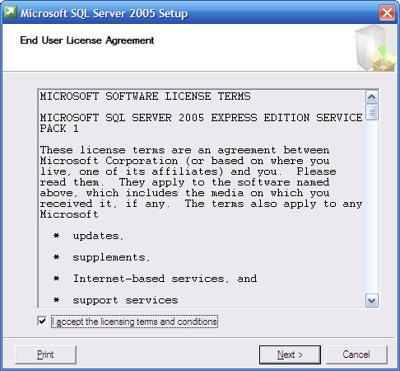

Prerequisites
Another screen appears. Press the install button to continue

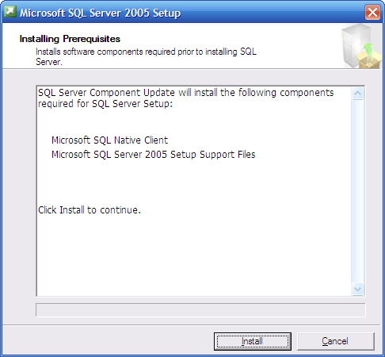

When its the prerequisites are installed the setup continues to install sql server itself. Again press the next button
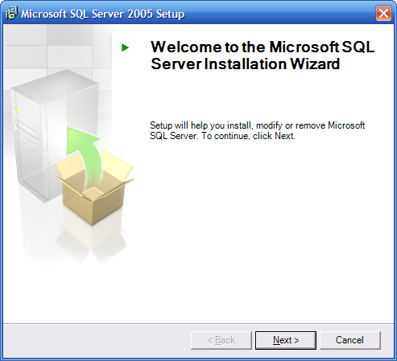

Setup will verify if all components are present and if so the following screen will be shown:
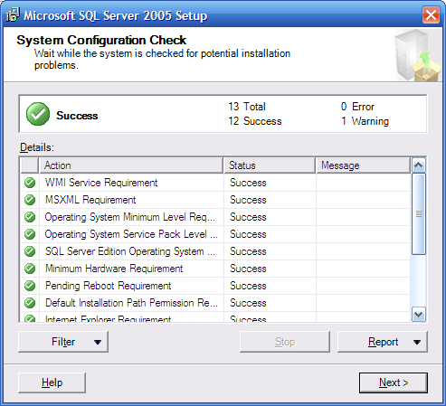

Registration
Press the next button, after a few seconds the setup asks for a registration name:
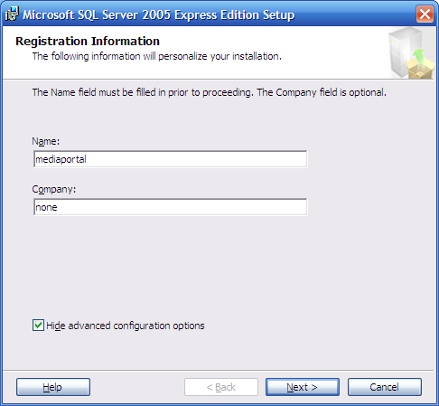

Choose any name you like, its not important and press next

Feature selection

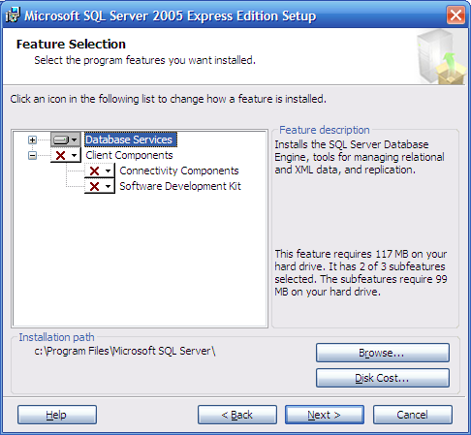

Here you can select which features to install. The default options are fine, but if you want to install SQL server on another drive then you can do that here
When done press next again

Authentication mode

The next screen is important!!!
Choose mixed mode and fill in a password for the sql server administrator account
Write down the password, we will need it later on!

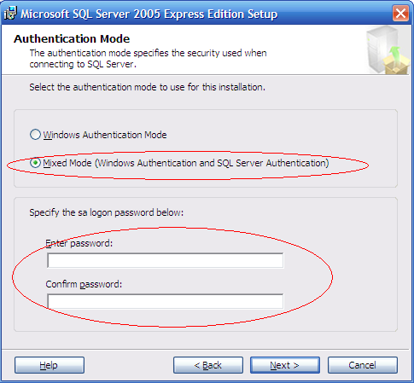

The following screen we can skip since the default options are ok. Simply press next again

Error and usage report settings
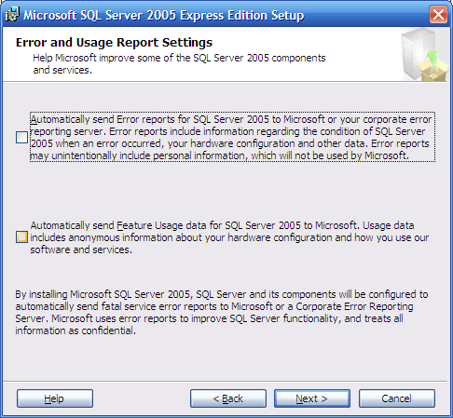

Again a screen (does it ever end?) press the install button
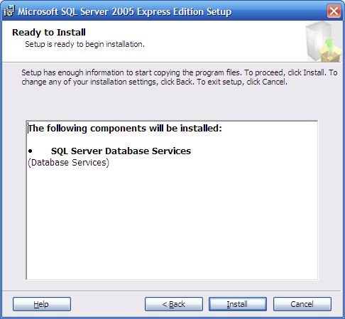

Yes! finally the installer decided to shut up and start doing what its supposed todo.
Sql server is being installed... time for a coffee

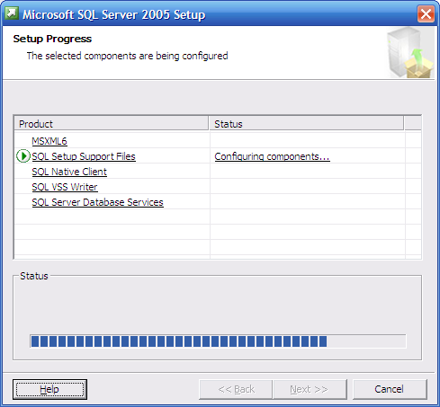

At the end the following screen is shown and you guessed it already, press next
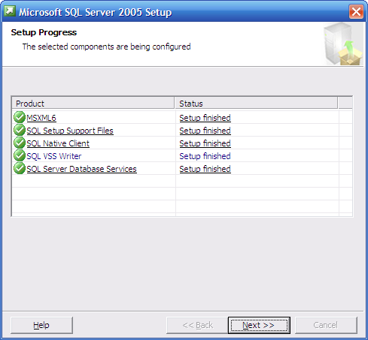

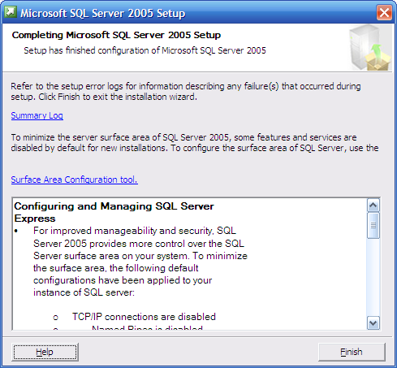

Press finish and we're done.

TV Server installation

The tv server can be installed by running setup.exe.
When run the following screen appears:
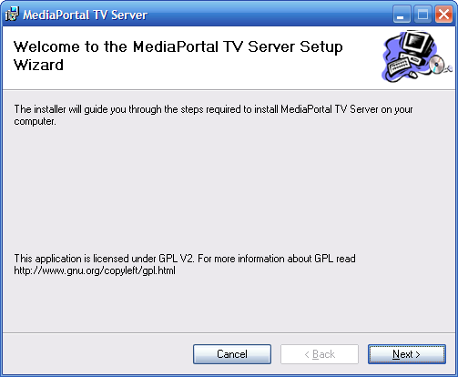

Press the next button

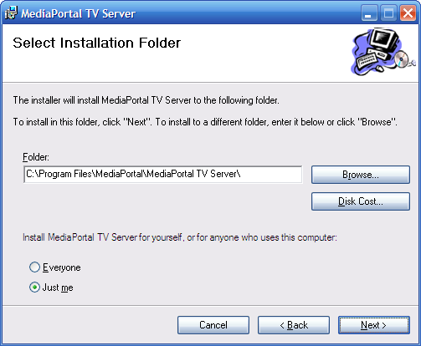

Here you can change the path where the tvserver should be installed.
Change it and/or press next to continue

In the following screen press next again to confirm the installation
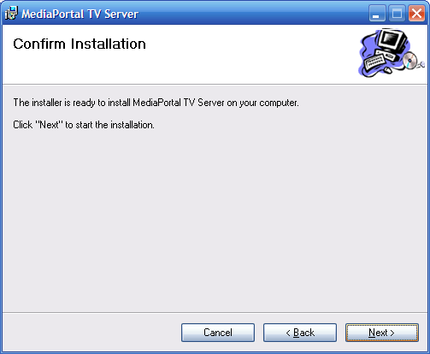

The tv server is being installed:
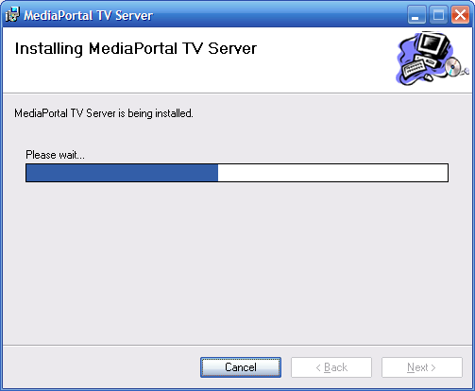

When its done the final screen is shown:
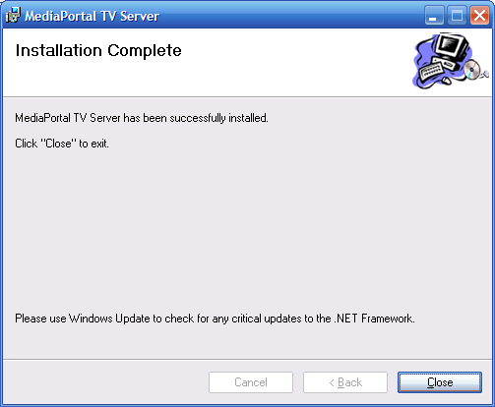

Press close to finish the installation.

TVServer configuration

In the folder in which we installed the tvserver you'll find setuptv.exe
(Its also on the start->TvServer menu)
Lets start it.

The following dialog appears:
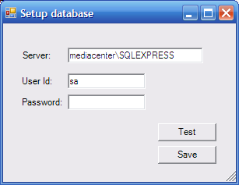

fill in the password of the SQL server sa account (told you to write it down!) and press the test button.

If all went ok you should see:
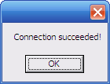
if not, fill in the correct details and try again.

When all is ok, press the Save button. Since this is the first time we start setuptv, it will create the TV database which takes a couple of seconds.
When its done the TV server configuration GUI appears:
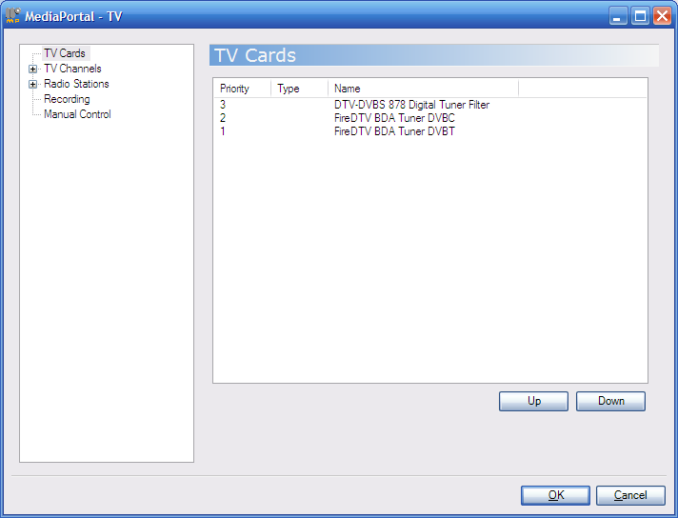

Here you can configure your TV cards, recording folders etc. We wont discuss it in this installation manual.

Installing the TV Plugin

Configuring MediaPortal
First make sure you have the latest svn version of MediaPortal installed, configured and running.
When done, run configuration.exe and remove all tv cards. This is needed since the tv server will handle all TV cards in the future and not MediaPortal.

Installing the TvServer plugin
Next run the tvplugin setup, the following screen appears:
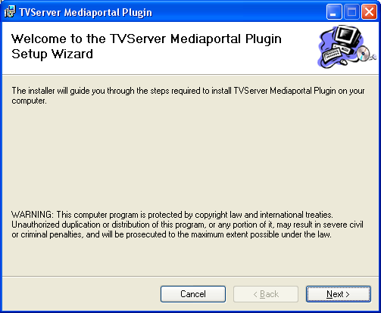

Press next to continue.

Changing the installation folder
In the following screen change the folder so it points to your MediaPortal directory

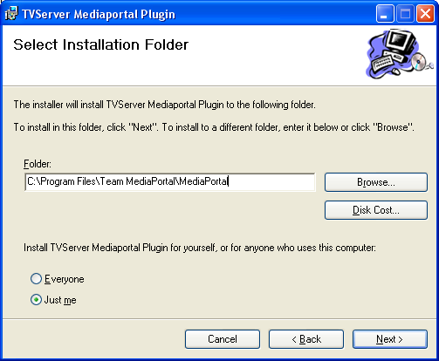
Press next to continue
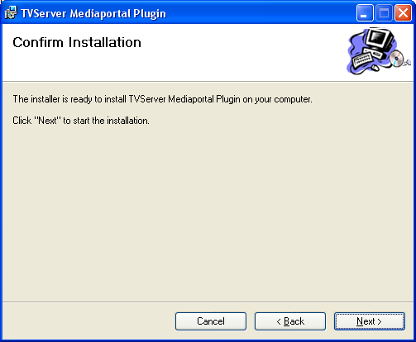
Again press next

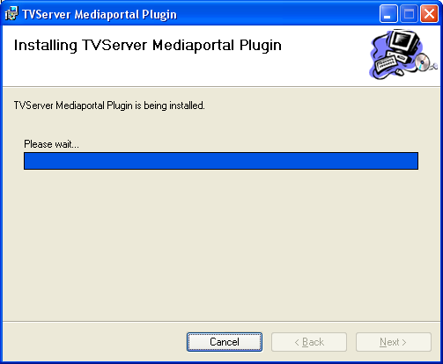

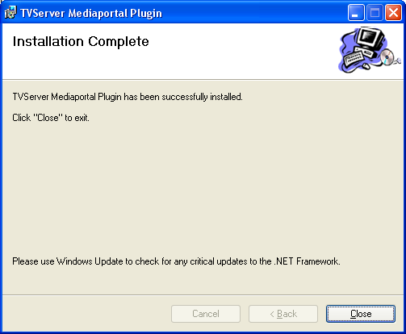

When installation has finished press close.

